COLLOQUIUM
Dr. Brock Williams
Texas Tech University
“Thinking Discretely”

Tuesday, September 25, 2012 at 3:30 p.m. in CH 113
Refreshments will be served in Math 238 at 3:00 p.m.

Abstract

We describe the development of a discrete form of complex analysis and Teichmüller theory using circle packings. This has in turn produced important advances in the classical theory. Moreover, the tools developed along the way have led to interesting biological applications.
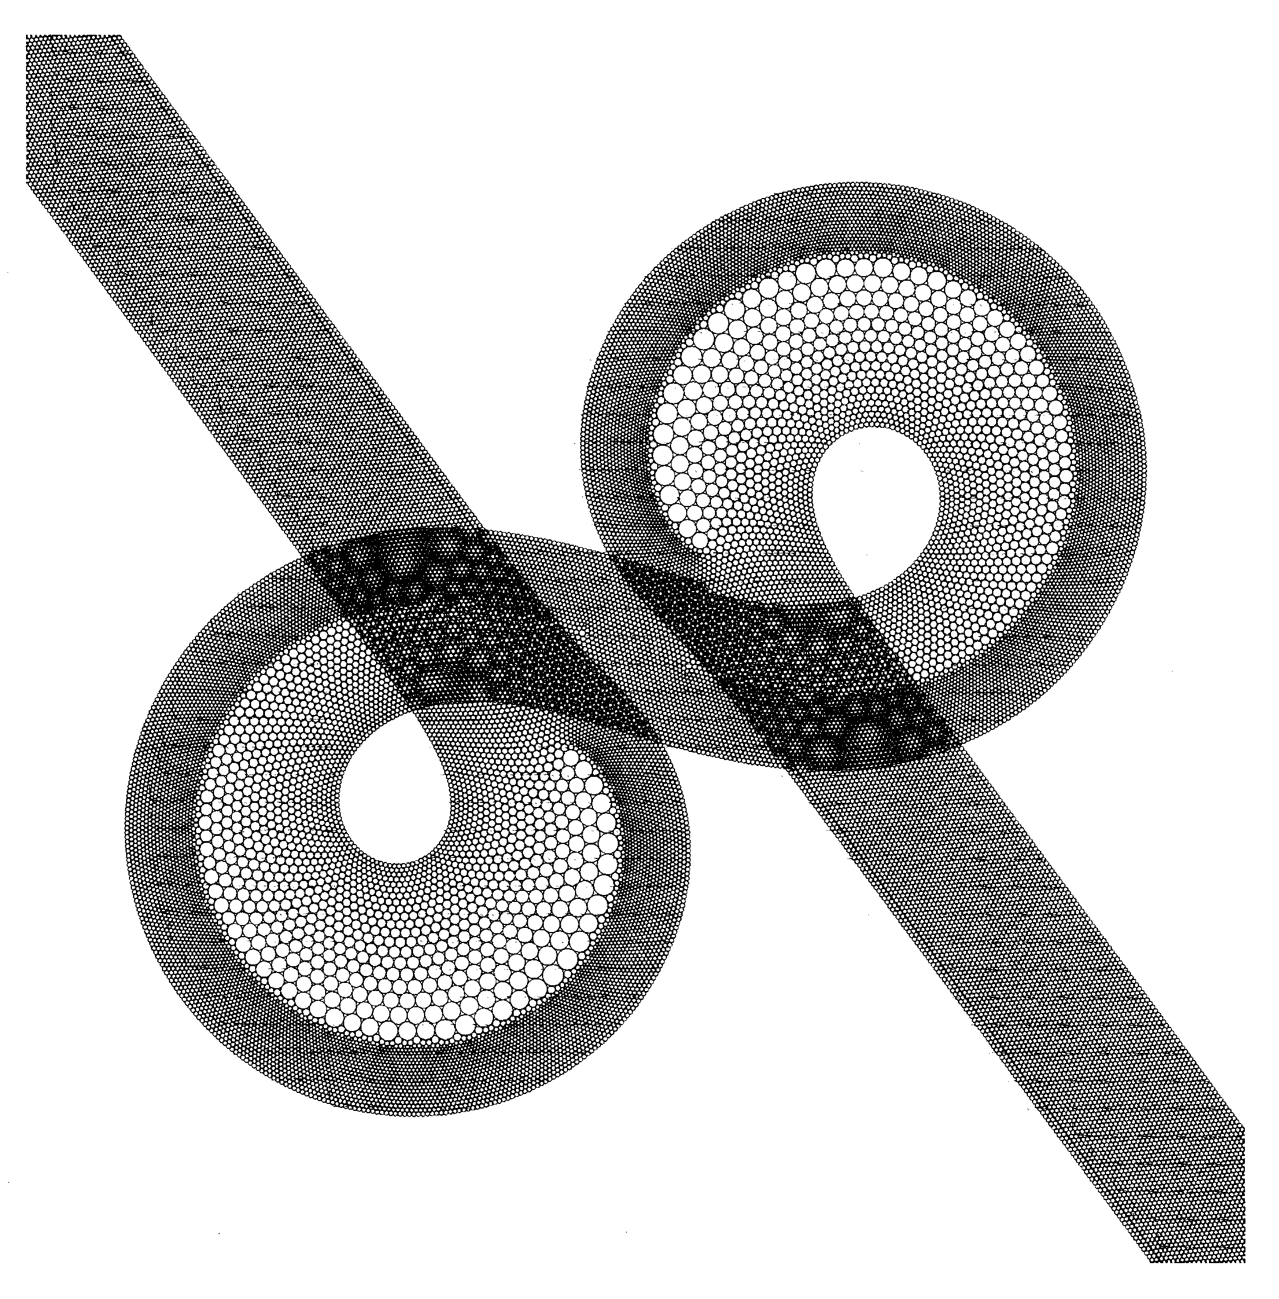
Brock Williams is a candidate for promotion.

